PROGRESSIVEREPORT–1(19/05/2025to03/06/2025)

# Project setup and ground floor layout

By creating an new Architectural template file our Initial stage of our Project begins.

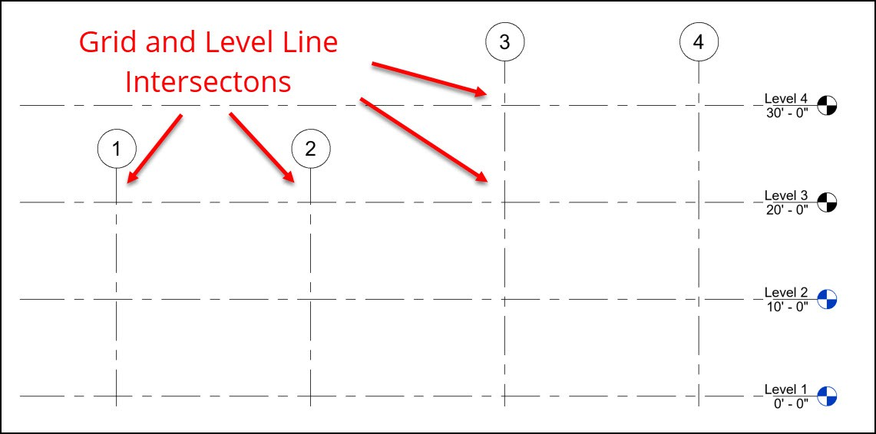

With the help of tool called user interface first we ensured the Presence of a property tool known as Project browser. The project browser plays an very important role in executing the overall building elevation and including ceiling planning as well as floor planning.

The Basic floor planning was done by using a tool called GRID. With the help of this tool, we constructed various Horizontal and Vertical grid lines with relative offset dimensions with respect to the layout of the plan. These Grid lines are mainly constructed in ground floor.

Further we renamed various level lines various respective Floors (ground floor, first floor). Before constructing the plan, we ensure changing the units into from Millimeters to Feet and Fractional inches which is necessary for development of plan. For the development of plan under grid lines Wall construction plays an very crucial role. Hence with the help of tool known as wall architecture we designed a basic generic masonry wall with required wall dimensions.

### Development of Plan with the help of above Gridlines constructed.

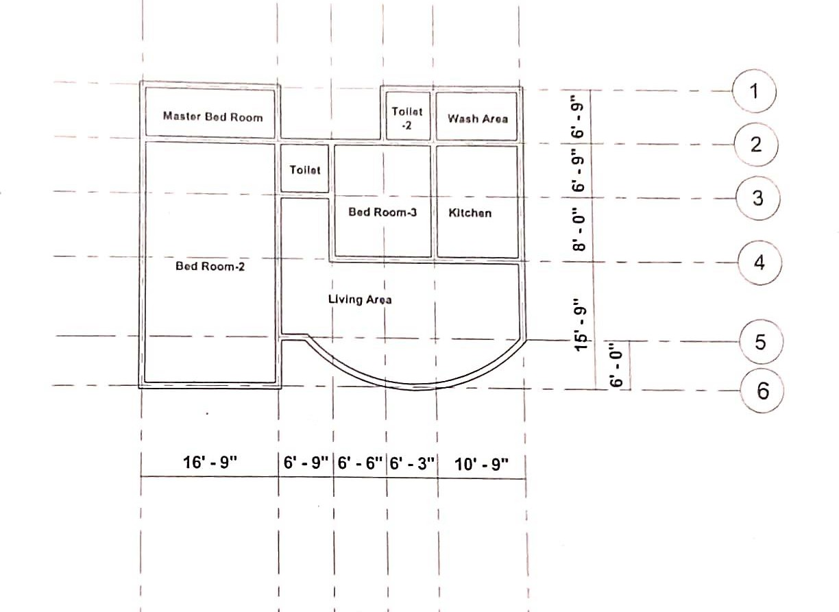

With the help of grid lines developed we further started constructing the Plan development by using the generic wall masonry with respective dimensions by the help of tool called wall architecture.

By offsetting the each wall distance and various set back distances the overall development of plan was done by dividing it into particular areas such as entrance, living area, kitchen, master bed room , Toilet, etc.

The overall Plan developed with the help of grid lines , the sectional view of the plan can be further view by tool called visual style which is present in bottom of property tool. This tool helps in developing sectional view of plan and as well as in identifying any mistakes taken place in the development of plan with respect to grid lines.

Through this we can ensure the enhancement and alteration of plan which can be helpful moreover in developing roofs and floors development in the plan.

The very next important thing is to connect the walls constructed in ground floors to the first floor of the building. This is done through a tool called Top constraint. This tool which is present in left corner of property called project browser plays an crucial role in connecting the walls of ground floor to the first floor as well as further top floors developed.

# First Floor staircase and ceiling integration

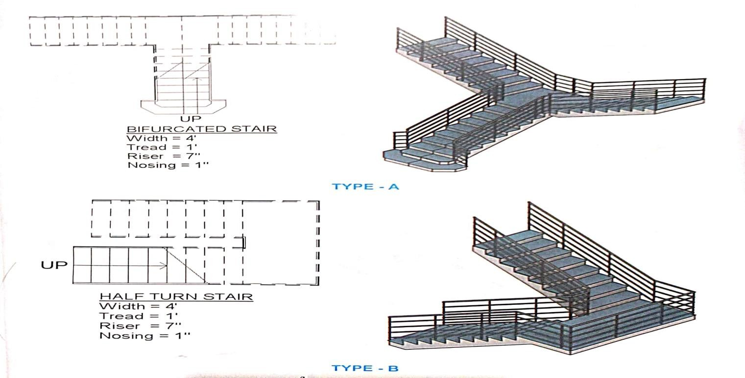

Moreover in further development of plan Doors, windows are been assigned to the particular areas by presetting there dimensions. The staircase is a critical vertical circulation element in the G+1 building, designed to connect the ground floor to the first floor while meeting functional, aesthetic, and regulatory requirements. The staircase is assumed to be an L-shaped reinforced concrete (RC) stair with a mid-landing, based on typical G+1.

Detailing and designing stair case is just done through Ensuring the stairwell location aligns with the grid for coordination with columns and walls by off setting the dimensions. with the help of Properties, we can select or create a new stair type (e.g., “Cast-in-Place Concrete Stair”).

We can also Edit the Riser Height, Tread Depth, Tread Thickness, Riser Type, Width, and design various staircase like round staircase, bifurcated staircase, half turn staircase geometrical half turned staircase, etc. With the help of 3D view we can confirm the stair passes through the opening correctly. Coordinate with Team Member 2 to ensure the ground floor layout supports the stair base.

### Construction of ceiling work.

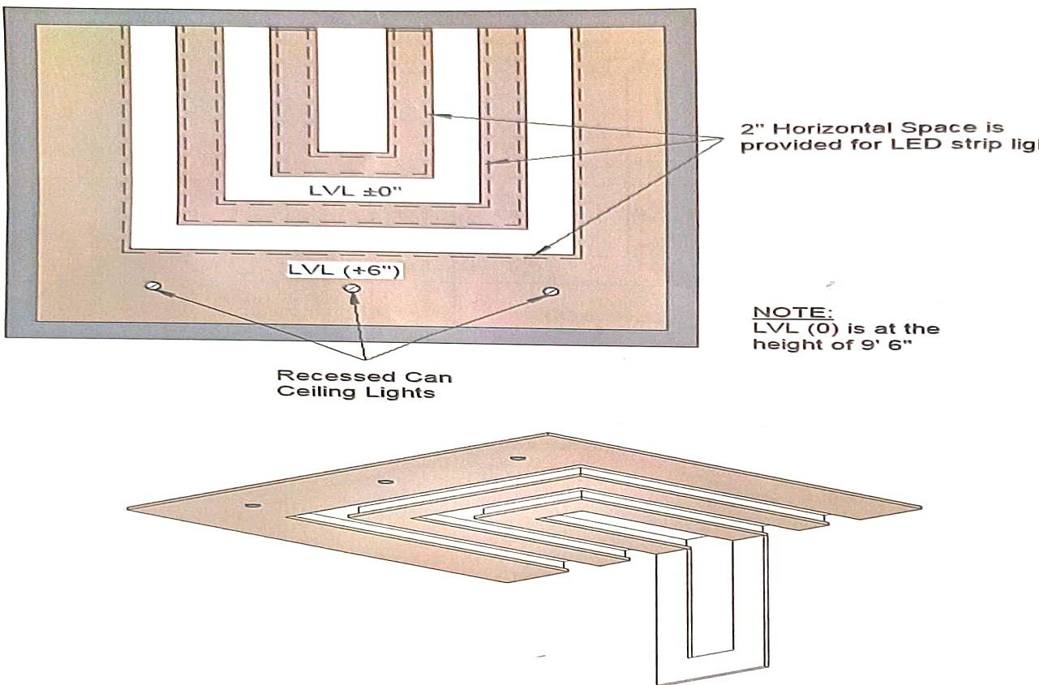

ConstructingaceilinginRevitArchitectureinvolvesseveralsteps,fromselecting the ceiling type to placing it correctly in your building model.

Construction level 1 Ceiling Plan, By selecting Ceiling Plan view (e.g., Level 1CeilingPlan). If no ceiling plans exist, we should first create one:(View tab

>Plan Views>Reflected Ceiling Plan.)

In the Properties palette, we can select a ceiling type(e.g., Compound Ceiling: Grid, or Generic) and through option called Edit Type we can Duplicate it to create a custom ceilings.

Selecting Automatic Ceiling from the options bar. Click inside a room or closed boundary to place a ceiling automatically. Choose Sketch Ceiling from the options bar. By Using Line, Rectangle, Arc, etc., to draw the ceiling outline. Finally by Clicking Finish (green check mark) total work of ceiling is done.

we can edit the ceiling sketch to change its shape or boundaries through the optionedittype.UsingSectionsor3DViewswecanverifytheplacementand alignment.

# Floor and Roof integration

### Constructing a first floor in Revit Architecture

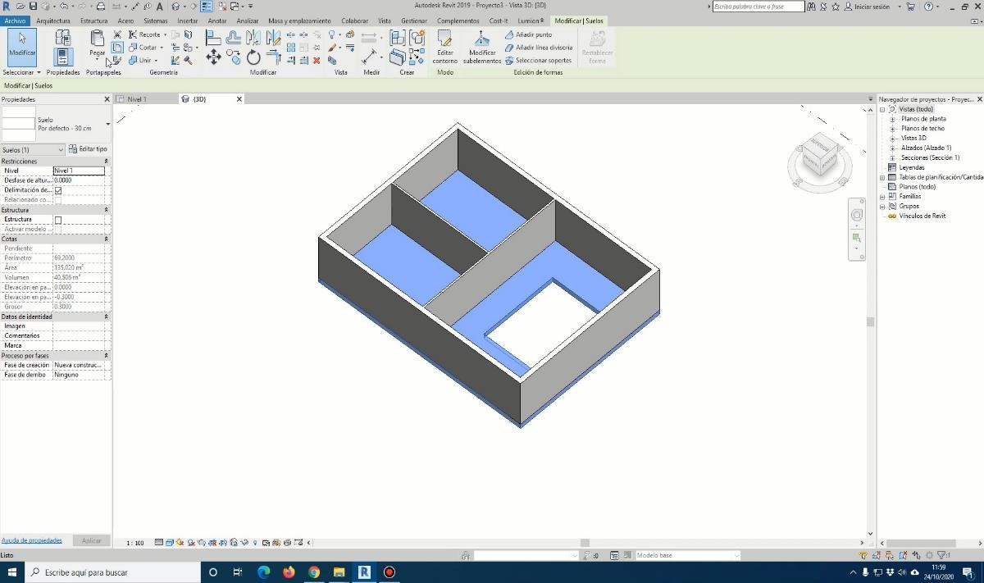

With the help of property called the Project Browser, selecting the Level1(ground floor) or the level corresponding to the first floor.

By Activating the Floor Tool by Going to the Architecture tab on the Ribbon. Click on Floor → select Floor: Architectural. This helps in overall construction of floor work.

Further by Drawing the Floor Boundary by Using drawing tools like: Pic wall line, rectangle circle, etc. with these tools we Ensured the boundary forms a closed loop.

Very next is the Floor Type In the Properties palette, we can select the desired floor type and To customize it, click Edit Type → further Duplicating it and by Editing the Structure to modify layers and materials.

By Using the Flip arrow or Offset tool we aligned the floor edge correctly with walls. Hence by Clicking the Green Checkmark (✔) on the Modify the overall CreateFloorBoundarytabtocompleted.ThoroughOpening3DViewweverified the floor placement and alignment with walls.

### To construct the roof for the first floor in Revit Architecture.

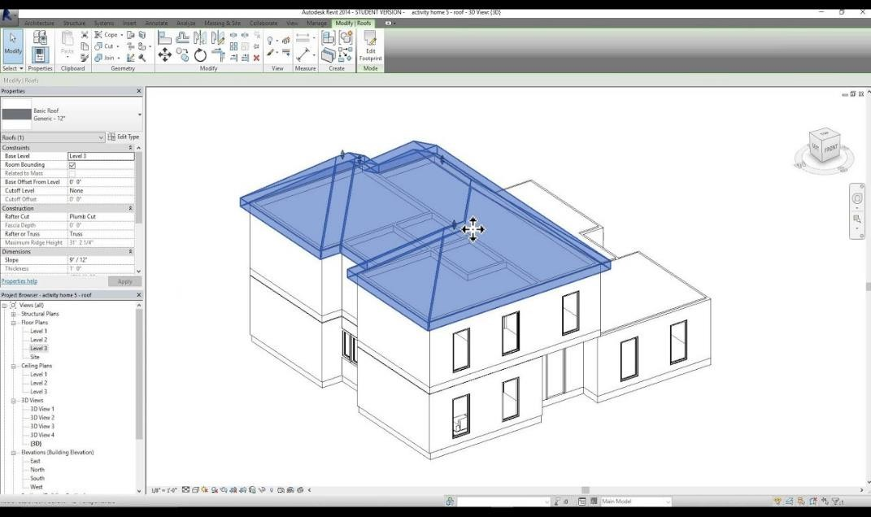

Very first stage of roof construction involves by Opening an Elevation View through the Project Browser. Open an Elevation view(e.g., South, East) to check or create the roof level above the first floor.

If a roof level doesn't exist. Go to Architecture tab → Click on the Level were roof need to be constructed, Place a level above the first floor (e.g., 3000 mm or 10 ft higher). Rename it to "Roof" or similar.

To Activate the Roof Tool, Go to the Architecture tab → Click on Roof through this we selected the method roof construction like Roof by Footprint or(most common) Roof by Extrusion, Roof by Face (for massing surfaces).

Very next step was to Draw the Roof Footprint. This was done through Using drawing tools like (e.g., Pick Walls, Line) to define the roof shape.

At last by Ensuring all lines forming a closed loop and Setting Roof Properties in the Properties palette, choose the desired roof type. By Modifying the roof type by clicking Edit Type → Duplicate → Edit Structure for custom materials/thickness.

Through Clicking the Green Check mark(✔)this indicates the overall completion of the roof sketch. Finally we can Review it in a 3D View that helps in verifying roof placement and ensure alignment with the building and with respective foors of building.